Visual Cues

1. Motion Parallax
   1. Monocular cue
   2. Objects that are nearer are moving **faster** and **backward**
   3. Objects that are farther are moving **slower** and **forward**

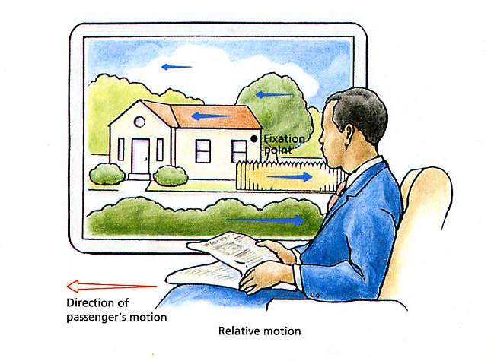

1. Interposition
   1. Monocular cue
   2. Blue overlaps the red, and hence closer to us

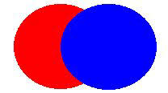

1. Shading and Contour
   1. Gives us 3D depth effect
   2. Dark region (indent)
   3. Bright region (hill)

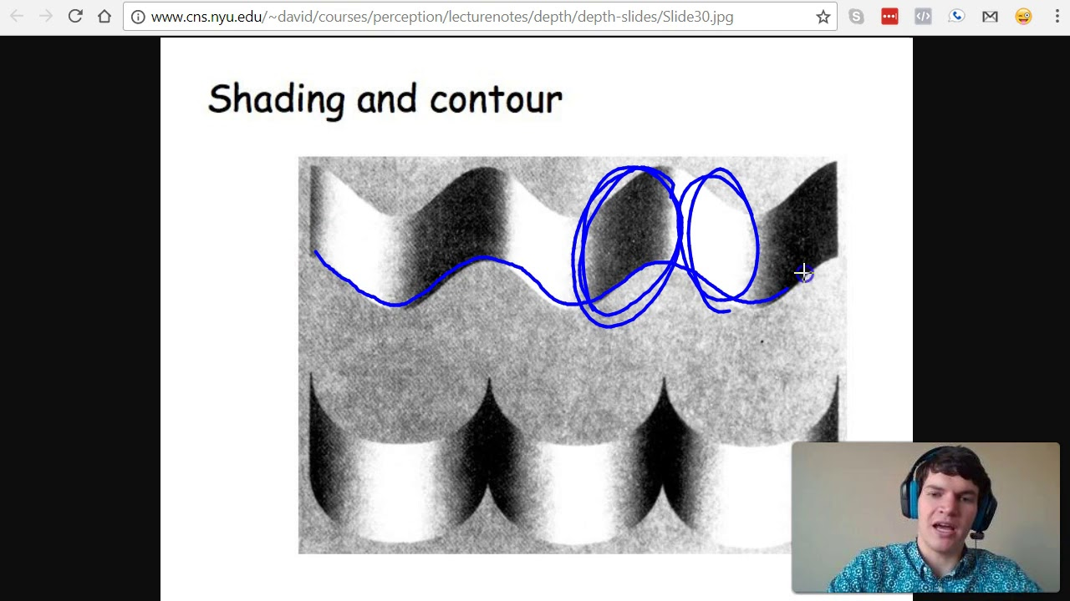

1. Convergence
   1. Imagine moving a pencil closer and closer to your eyes
   2. The closer the object, the more our eyes are going to turn inward (until you are cross-eyed)

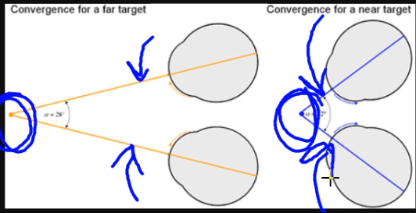

1. Retinal Disparity
   1. Binocular cue
   2. The more disparity between the images you are seeing (with your left and right eyes), the more your brain will interpret that object as being closer
   3. Our brain can take these two images and convert them into one

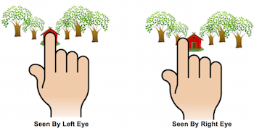

The Visual Information Pathway

* The optic chiasm ensures that:
* All information from the left visual field gets processed on the right side of the brain
* All information from the right visual field gets processed on the left side of the brain
* Note that each visual field is not the same as what each eye will process; each eye processes both visual fields

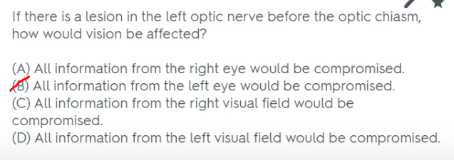

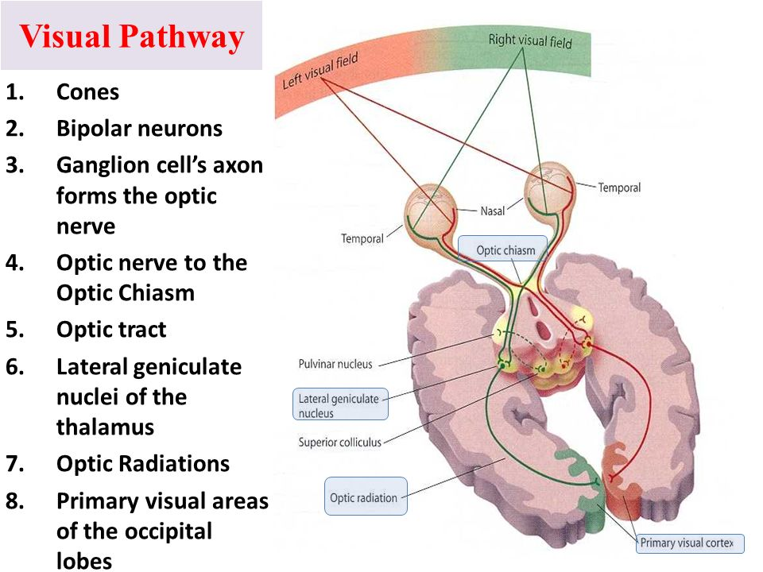

Electronegativity and Bonding

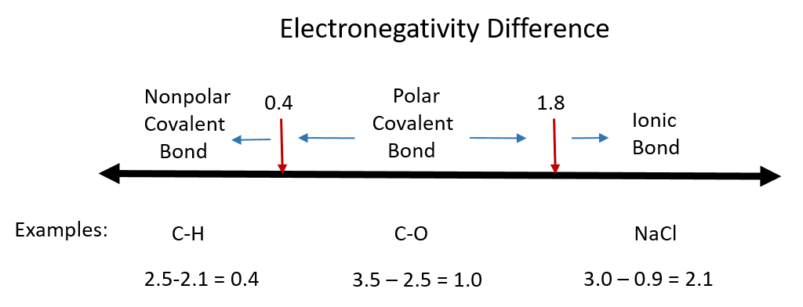

Poiseuille’s Law

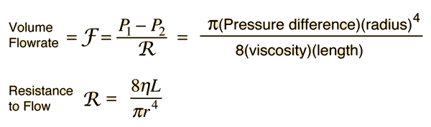

Differences in stereoisomers

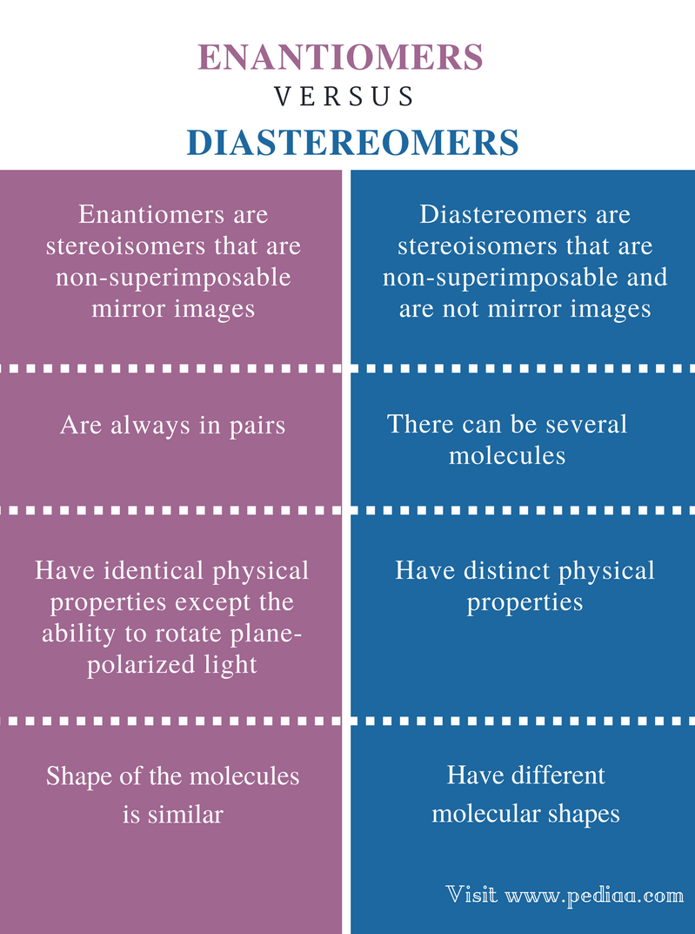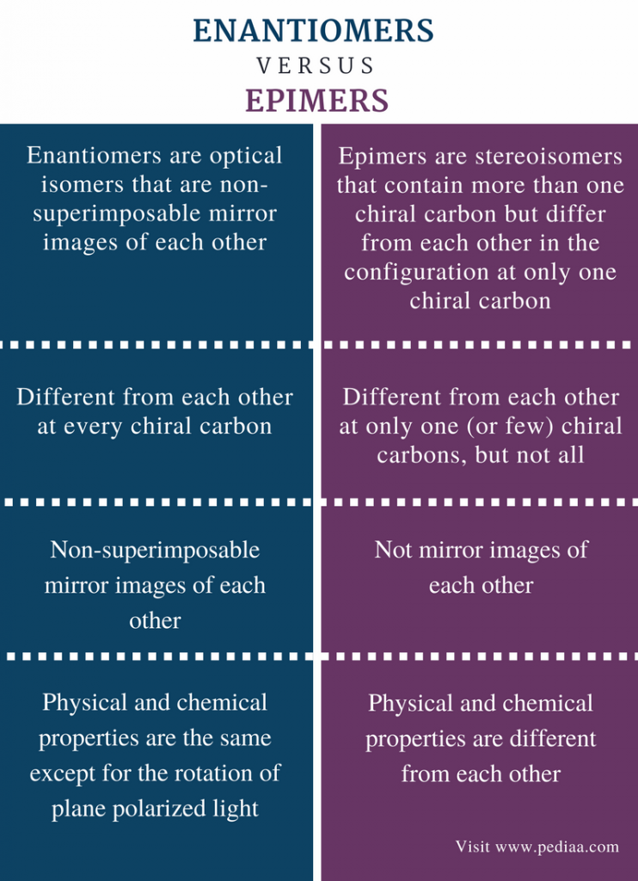

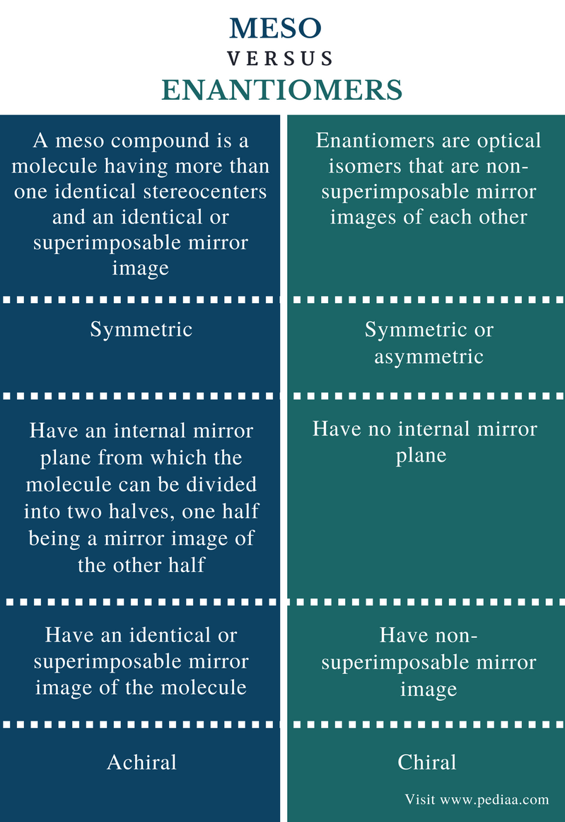

Doppler Effect

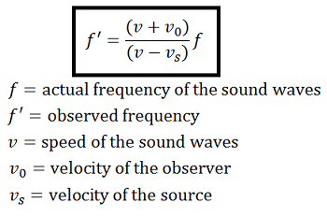

Psychoanalytic Theory vs Force Field Analysis vs Fictional Finalism

* Psychoanalytic Theory
  + Focuses on how past experiences e.g. childhood have influenced your unconscious
* Force Field Analysis
  + Focuses only on the current factors that are affecting your behavior (whether they are leading you towards or away from actualization)
* Fictional Finalism
  + We are more motivated by things that don’t exist e.g. the future and our expectations for the future than our past experiences

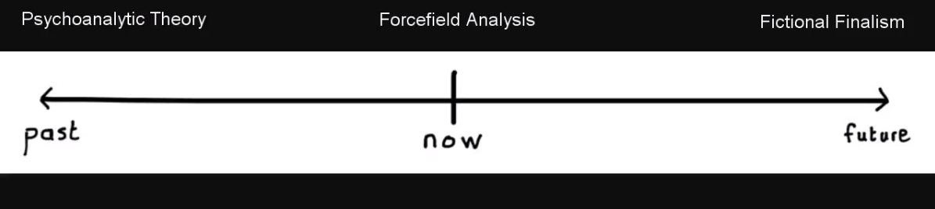

Polarimeter Tubes and Observed Rotation

* How it works
  + Polarized light at Point 4
  + Chiral Compound at Point 5 → causes rotation of light (in this case, anticlockwise)
  + Adjustment at Point 7 (until you can see)
  + Observed rotation detected at Point 8

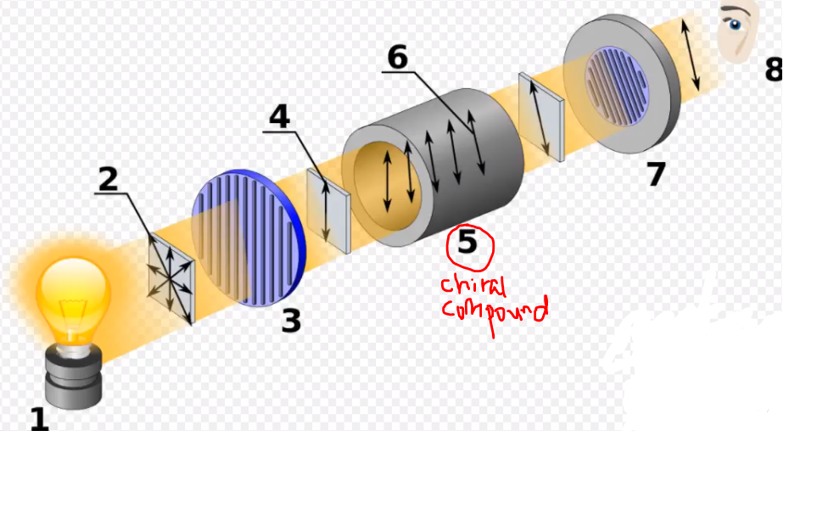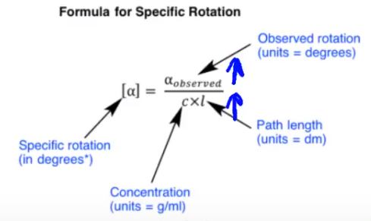

* Specific rotation stays constant
  + Increased concentration of chiral compound → increased observed rotation
    - More chiral compound to rotate the light
  + Increased path length (doubling the length of the tube) → increased observed rotation
    - More time to rotate the light in the tube

Hybridization and Wave Number

* In increasing order of wavenumber:
  + Csp3-H << Csp2-H << Csp-H
* More %s character → more bond strength → higher frequency → higher wavenumber

Reference Group

* Two conditions:
  + The reference is a group (therefore you can eliminate those answers that are referring to a single person)
  + The reference group acts as a standard for evaluating your own behavior

Authoritarian Personality Type

* Militaristic; harsh upbringing and disciplining
* Characterized by obedience and submission to superiors, and oppression toward subordinates, rigidity and inflexibility as well
* Use prejudice to help them cope with their world view
  + Protects their ego
  + Avoids the need to control aspects of themselves

Ordering boiling points

* LDF < HB
* Ketone has higher boiling point than aldehyde because the carbonyl group is more polar

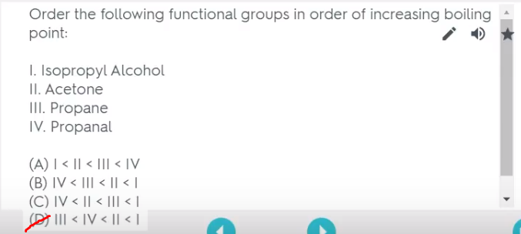

Reducing Agents

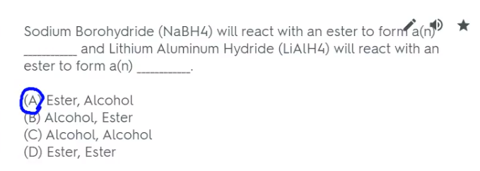

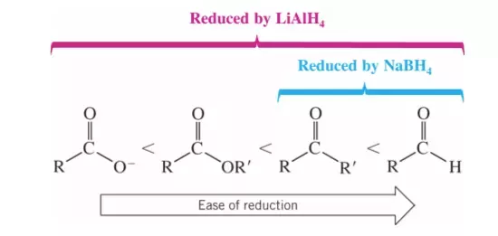

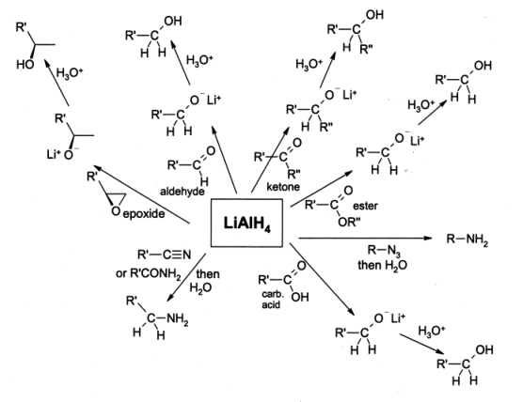

Stranger Anxiety

* Developmental milestone at **8 months old**: Starts to become fearful of anyone (including close friends) who is not his/her parent
* Note that the child was not fearful of strangers before 8 months old

Normal cells vs Cancer cells

* Normal cells spend more time in **interphase**
* Cancer cells spend more time in **mitosis**

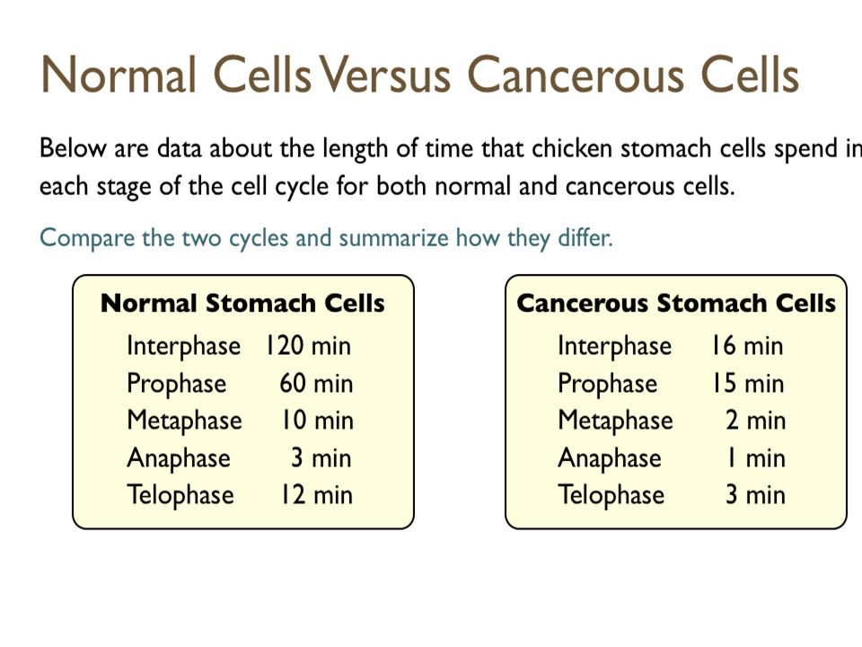

Carboxylic Acid and Amide Reactivity

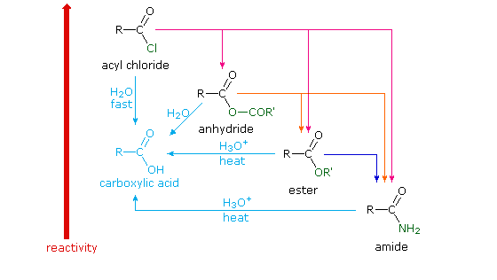

* Exception to the rule: NH3 + COOH
  + Because both their reactivities are so close
  + NH3 acts as a bronsted base instead of a nucleophile

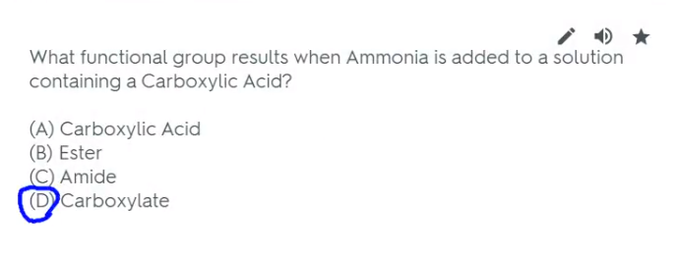

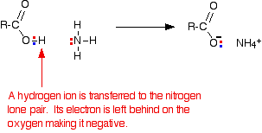

Boiling Point, Freezing Point and Pressure

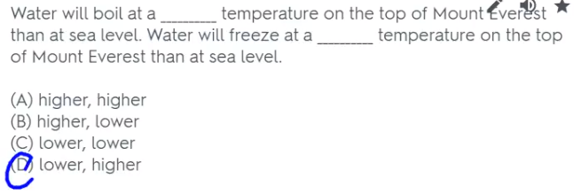

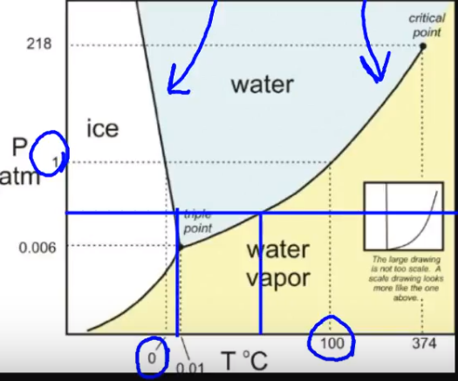

Gatekeeping

* Those who control the kind of information we receive

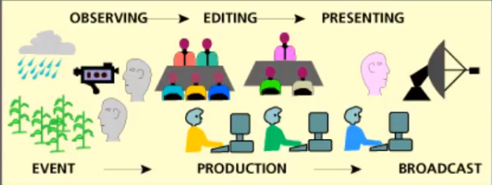

Cultural Universals

* They are things that are present and universal in all cultures
* E.g. you expect to find some form of education (whether it is formal/informal or in the form of school/ parent teaching) in every culture

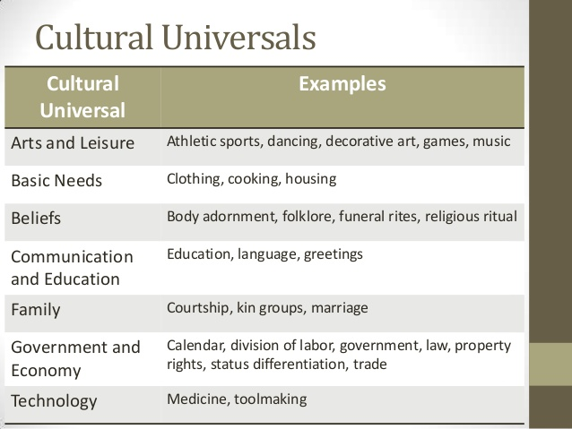

Tokenism

* Not actually intent on having diversity in the workplace because they want diversity
* They include that one diverse character e.g. black person among the whites to put on a show